**LEMBAR PROGRES**

**UKK 2021 - Aplikasi Pembayaran SPP**

**NIS : 195051289065**

**NAMA : Ryan Adi Saputra**

**KELAS : XII RPL A**

**E-MAIL :** **riyanadi552@gmail.com**

**PROGRES KE : 3**

**KETENTUAN UMUM :**

1. Setiap progres, wajib menyertakan kode program (*source code*) dan print screen hasil secara lengkap
2. Wajib melakukan progres minimal 5 Kali sebelum tanggal 19 April 2021
3. Untuk ikut UKK wajib menyelesaikan 75% projek

**KETENTUAN TEKNIS :**

* Convert Lembar Progres ini ke dalam format **PDF (.pdf)**, untuk di upload di **Google Form yang telah disediakan**
* Ganti nama file pdf dengan format: **NoAbsen_Nama_Kelas_ProgresKe**

**(contoh : 01_Andi Ronaldo_XII RPL B_1)**

* Ukuran file maksimal : **3 MB**

# HASIL PROGRES

# Pada progress ke-3 ini saya, telah menyelesaikan crud spp dan crud siswa beserta halamannya yang hanya bisa diakses oleh admin saja. Sekian dan terimakasih.

# Kode program :

1. Menambahkan beberapa syntax di awal dan di akhir fungsi pada setiap fungsi tambah, ubah, dan delete untuk membatasi hak akses pada tambah, ubah, dan delete petugas maupun kelas di bagian Controller Petugas.php dan Kelas.php pada progress 2 (catatan : contohnya seperti pada Controller Spp.php dan Siswa.php)

// nama fungsi

{

        if($this->session->userdata('level') == 'Administrator') {

// ...

       // isi fungsi

// ...

        }else{

            redirect('dashboard');

        }

    }

1. Controller Spp.php

<?php

defined('BASEPATH') or exit('No direct script access allowed');

/*

 * author ryanadi

 */

*class* Spp extends *CI_Controller*

{

    public *function* __construct()

    {

*parent*::__construct();

        $this->load->model('M_Admin');

        $this->load->library('form_validation');

    }

    //halaman spp

    public *function* index()

    {

        if($this->session->userdata('level') == 'Administrator') {

            $data['title'] = 'Preparation SPP';

            $data['app'] = 'Bayar SPP';

            $data['user'] = $this->M_Admin->datauser();

            $this->template->load('admin/template', 'admin/spp/spp', $data);

        }else{

            redirect('dashboard');

        }

    }

    //table spp

    public *function* index_ajax($start = null)

    {

        if($this->session->userdata('level') == 'Administrator') {

            $cari =  htmlspecialchars($this->input->post('cari'), true);

            $cari_key = [

                'tahun' => $cari,

                'nominal' => $cari,

            ];

            $start = ($this->uri->segment(3)) ? $this->uri->segment(3) : 0;

            // config

            $config['base_url'] = 'http://localhost/trial_ukk/01-preparation/preparation/spp/index_ajax';

            $config['per_page'] = 5;

            $config['total_rows'] = $this->M_Admin->getSpp($config['per_page'], $start, $count = true, $cari_key);

            $this->pagination->initialize($config);

            $data['total'] = $config['total_rows'];

            $data['no'] = $start;

            $data['spp'] = $this->M_Admin->getSpp($config['per_page'], $start, $count = false, $cari_key);

            $data['pagelinks'] = $this->pagination->create_links();

            $this->load->view('admin/spp/table', $data);

        }else{

            redirect('dashboard');

        }

    }

    //tambah spp

    public *function* tambah_spp()

    {

        if($this->session->userdata('level') == 'Administrator') {

            $this->form_validation->set_rules('tahun', 'Tahun', 'required|trim|min_length[4]|integer', [

                'required' => 'Tahun harus diisi!',

                'integer' => 'Tahun harus berupa bilangan bulat'

            ]);

            $this->form_validation->set_rules('nominal', 'Nominal', 'required|trim|numeric|integer', [

                'required' => 'Nominal harus diisi!',

                'numeric'  => 'Jumlah harus berupa angka bilangan bulat',

                'integer'  => 'Angka harus berupa bilangan bulat, tanpa karakter lainya'

            ]);

            if ($this->form_validation->run() == false) {

                $data['title'] = 'Preparation SPP';

                $data['app'] = 'Bayar SPP';

                $data['user'] = $this->M_Admin->datauser();

                $this->template->load('admin/template', 'admin/spp/tambahspp', $data);

            }

            else {

                $this->M_Admin->tambah_spp();

                $this->session->set_flashdata('message', '<div class="alert alert-success mx-auto alert-dismissible fade show" role="alert">Data spp berhasil ditambahkan!<button type="button" class="close" data-dismiss="alert" aria-label="Close"><span aria-hidden="true">&times;</span></button></div>');

                redirect('spp');

            }

        }else{

            redirect('dashboard');

        }

    }

    //ubah spp

    public *function* ubah_spp($id)

    {

        if($this->session->userdata('level') == 'Administrator') {

            $data['title'] = 'Preparation SPP';

            $data['app'] = 'Bayar SPP';

            $data['user'] = $this->M_Admin->datauser();

            $data['detail'] = $this->M_Admin->getDataSpp($id);

            $this->form_validation->set_rules('tahun', 'Tahun', 'required|trim|min_length[4]|integer', [

                'required' => 'Tahun harus diisi!',

                'integer' => 'Tahun harus berupa bilangan bulat'

            ]);

            $this->form_validation->set_rules('nominal', 'Nominal', 'required|trim|numeric|integer', [

                'required' => 'Nominal harus diisi!',

                'numeric'  => 'Jumlah harus berupa angka bilangan bulat',

                'integer'  => 'Angka harus berupa bilangan bulat, tanpa karakter lainya'

            ]);

            if ($this->form_validation->run() == false) {

                $this->template->load('admin/template', 'admin/spp/ubahspp', $data);

            } else {

                $data = [

                    'tahun' => $this->input->post('tahun', true),

                    'nominal' => $this->input->post('nominal', true),

                ];

                $where = [

                    'id_spp' => $this->input->post('id_spp')

                ];

                $this->M_Admin->ubah_spp($data, $where);

                $this->session->set_flashdata('message', '<div class="alert alert-success mx-auto alert-dismissible fade show" role="alert">Data spp berhasil diubah!<button type="button" class="close" data-dismiss="alert" aria-label="Close"><span aria-hidden="true">&times;</span></button></div>');

                redirect('spp');

            }

        }else{

            redirect('dashboard');

        }

    }

    //delete spp

    public *function* delete_spp($id)

    {

        if($this->session->userdata('level') == 'Administrator') {

            $this->M_Admin->delete_spp($id);

            $this->session->set_flashdata('message', '<div class="alert alert-success mx-auto alert-dismissible fade show" role="alert">Data spp berhasil dihapus!<button type="button" class="close" data-dismiss="alert" aria-label="Close"><span aria-hidden="true">&times;</span></button></div>');

            redirect('spp');

        }else{

            redirect('dashboard');

        }

    }

}

?>

1. Controller Siswa.php

<?php

defined('BASEPATH') or exit('No direct script access allowed');

/*

 * author ryanadi

 */

*class* Siswa extends *CI_Controller*

{

    public *function* __construct()

    {

*parent*::__construct();

        $this->load->model('M_Admin');

        $this->load->library('form_validation');

    }

    //halaman siswa

    public *function* index()

    {

        if($this->session->userdata('level') == 'Administrator') {

            $data['title'] = 'Preparation SPP';

            $data['app'] = 'Bayar SPP';

            $data['user'] = $this->M_Admin->datauser();

            $this->template->load('admin/template', 'admin/siswa/siswa', $data);

        }else{

            redirect('dashboard');

        }

    }

    //table siswa

    public *function* index_ajax($start = null)

    {

        if($this->session->userdata('level') == 'Administrator') {

            $cari =  htmlspecialchars($this->input->post('cari'), true);

            $cari_key = [

                'nisn' => $cari,

                'nis' => $cari,

                'nama_siswa' => $cari,

                'alamat' => $cari,

                'no_telepon' => $cari,

                'nama_kelas' => $cari,

                'tahun' => $cari,

            ];

            $start = ($this->uri->segment(3)) ? $this->uri->segment(3) : 0;

            // config

            $config['base_url'] = 'http://localhost/trial_ukk/01-preparation/preparation/siswa/index_ajax';

            $config['per_page'] = 5;

            $config['total_rows'] = $this->M_Admin->getSiswa($config['per_page'], $start, $count = true, $cari_key);

            $this->pagination->initialize($config);

            $data['total'] = $config['total_rows'];

            $data['no'] = $start;

            $data['siswa'] = $this->M_Admin->getSiswa($config['per_page'], $start, $count = false, $cari_key);

            $data['pagelinks'] = $this->pagination->create_links();

            $this->load->view('admin/siswa/table', $data);

        }else{

            redirect('dashboard');

        }

    }

    //tambah siswa

    public *function* tambah_siswa()

    {

        if($this->session->userdata('level') == 'Administrator') {

            $data['title'] = 'Preparation SPP';

            $data['app'] = 'Bayar SPP';

            $data['user'] = $this->M_Admin->datauser();

            $data['siswa'] = $this->M_Admin->getDataSiswa();

            $data['kelas'] = $this->M_Admin->getAllKelas();

            $data['spp'] = $this->M_Admin->getAllSpp();

            $this->form_validation->set_rules('nisn', 'NISN', 'required|trim|numeric|integer|is_unique[siswa.nisn]', [

                'required' => 'NISN harus diisi!',

                'numeric'  => 'NISN harus berupa angka!',

                'integer'  => 'NISN hanya berupa bilangan bulat',

                'is_unique' => 'NISN sudah terdaftar'

            ]);

            $this->form_validation->set_rules('nis', 'NIS', 'required|trim|numeric|integer|is_unique[siswa.nis]', [

                'required' => 'NIS harus diisi!',

                'integer' => 'NIS hanya berupa bilangan bulat!',

                'numeric'  => 'NIS harus berupa angka!',

                'is_unique' => 'NIS sudah terdaftar'

            ]);

            $this->form_validation->set_rules('nama_siswa', 'Nama_Siswa', 'required|trim', [

                'required' => 'Nama siswa harus diisi!'

            ]);

            $this->form_validation->set_rules('no_telepon', 'No_Telepon', 'required', [

                'required' => 'No. Telepon harus diisi!'

            ]);

            $this->form_validation->set_rules('id_kelas', 'Kelas', 'required', [

                'required' => 'Kelas harus dipilih'

            ]);

            $this->form_validation->set_rules('id_spp', 'SPP', 'required', [

                'required' => 'SPP harus dipilih'

            ]);

            $this->form_validation->set_rules('alamat', 'Alamat', 'required', [

                'required' => 'Alamat harus diisi!'

            ]);

            if ($this->form_validation->run() == false) {

                $this->template->load('admin/template', 'admin/siswa/tambahsiswa', $data);

            }

            else {

                $this->M_Admin->tambah_siswa();

                $this->session->set_flashdata('message', '<div class="alert alert-success mx-auto alert-dismissible fade show" role="alert">Data siswa berhasil ditambahkan!<button type="button" class="close" data-dismiss="alert" aria-label="Close"><span aria-hidden="true">&times;</span></button></div>');

                redirect('siswa');

            }

        }else{

            redirect('dashboard');

        }

    }

    //ubah siswa

    public *function* ubah_siswa($nisn)

    {

        if($this->session->userdata('level') == 'Administrator') {

            $data['title'] = 'Preparation SPP';

            $data['app'] = 'Bayar SPP';

            $data['user'] = $this->M_Admin->datauser();

            $data['detail'] = $this->M_Admin->getAllSiswa($nisn);

            $data['siswa'] = $this->M_Admin->getDataSiswa();

            $this->form_validation->set_rules('nisn', 'NISN', 'required|trim|numeric|integer', [

                'required' => 'NISN harus diisi!',

                'numeric'  => 'NISN harus berupa angka!',

                'integer'  => 'NISN hanya berupa bilangan bulat',

            ]);

            $this->form_validation->set_rules('nis', 'NIS', 'required|trim|numeric|integer', [

                'required' => 'NIS harus diisi!',

                'integer' => 'NIS hanya berupa bilangan bulat!',

                'numeric'  => 'NIS harus berupa angka!',

            ]);

            $this->form_validation->set_rules('nama_siswa', 'Nama_Siswa', 'required|trim', [

                'required' => 'Nama siswa harus diisi!'

            ]);

            $this->form_validation->set_rules('no_telepon', 'No_Telepon', 'required', [

                'required' => 'No. Telepon harus diisi!'

            ]);

            $this->form_validation->set_rules('id_kelas', 'Kelas', 'required', [

                'required' => 'Kelas harus dipilih'

            ]);

            $this->form_validation->set_rules('id_spp', 'SPP', 'required', [

                'required' => 'SPP harus dipilih'

            ]);

            $this->form_validation->set_rules('alamat', 'Alamat', 'required', [

                'required' => 'Alamat harus diisi!'

            ]);

            if ($this->form_validation->run() == false) {

                $this->template->load('admin/template', 'admin/siswa/ubahsiswa', $data);

            }

            else {

                $data = [

                    'nis' => $this->input->post('nis', true),

                    'nama_siswa' => $this->input->post('nama_siswa', true),

                    'no_telepon' => $this->input->post('no_telepon', true),

                    'id_kelas' => $this->input->post('id_kelas', true),

                    'id_spp' => $this->input->post('id_spp', true),

                    'alamat' => $this->input->post('alamat', true)

                ];

                $where = [

                    'nisn' => $this->input->post('nisn', true),

                ];

                $this->M_Admin->ubah_siswa($data, $where);

                $this->session->set_flashdata('message', '<div class="alert alert-success mx-auto alert-dismissible fade show" role="alert">Data siswa berhasil diubah!<button type="button" class="close" data-dismiss="alert" aria-label="Close"><span aria-hidden="true">&times;</span></button></div>');

                redirect('siswa');

            }

        }else{

            redirect('dashboard');

        }

    }

    //detail siswa

    public *function* detail_siswa($nisn)

    {

        if($this->session->userdata('level') == 'Administrator') {

            $data['title'] = 'Preparation SPP';

            $data['app'] = 'Bayar SPP';

            $data['user'] = $this->M_Admin->datauser();

            $data['detail'] = $this->M_Admin->getAllSiswa($nisn);

            $data['siswa'] = $this->M_Admin->getDataSiswa();

            $this->template->load('admin/template', 'admin/siswa/detailsiswa', $data);

        }else{

            redirect('dashboard');

        }

  }

    //delete siswa

    public *function* delete_siswa($nisn)

    {

        if($this->session->userdata('level') == 'Administrator') {

            $this->M_Admin->delete_siswa($nisn);

            $this->session->set_flashdata('message', '<div class="alert alert-success mx-auto alert-dismissible fade show" role="alert">Data siswa berhasil dihapus!<button type="button" class="close" data-dismiss="alert" aria-label="Close"><span aria-hidden="true">&times;</span></button></div>');

            redirect('siswa');

        }else{

            redirect('dashboard');

        }

    }

}

?>

1. Model M_Admin.php (update)

<?php

defined('BASEPATH') or exit('No direct script access allowed');

/**

 * author ryanadi

 */

*class* M_Admin extends *CI_Model*

{

    public *function* __construct()

    {

*parent*::__construct();

    }

    //cek login

    public *function* getUsername($username)

    {

        return $this->db->get_where('petugas', ['username' => $username])->row_array();

    }

    public *function* getNisn($nisn)

    {

        return $this->db->get_where('siswa', ['nisn' => $nisn])->row_array();

    }

    //datauser / session

    public *function* datauser()

    {

        return $this->db->get_where('petugas', ['username' => $this->session->userdata('username')])->row_array();

    }

    //tambah petugas

    public *function* tambah_petugas()

    {

        $data = [

            'username' => htmlspecialchars($this->input->post('username', true)),

            'nama_petugas' => htmlspecialchars($this->input->post('nama_petugas', true)),

            'password' => password_hash($this->input->post('password'), PASSWORD_DEFAULT),

            'level' => 'Petugas',

            'status' => 1,

        ];

        $this->db->insert('petugas', $data);

    }

    //ambil data petugas

    public *function* getDataPetugas($id)

    {

        return $this->db->get_where('petugas', ['id_petugas' => $id])->row_array();

    }

    //ambil data petugas

    public *function* getPetugas($limit = null, $start = null, $count = true, $cari = null)

    {

        $this->db->select('*');

        $this->db->from('petugas');

        if ($cari != null) {

            foreach ($cari as $keyc => $valuec) {

                $this->db->or_like($keyc, $valuec);

            }

        }

        if ($count) {

            return $this->db->count_all_results();

        } else {

            $this->db->limit($limit, $start);

            $query = $this->db->get();

            if ($query->num_rows()  > 0) {

                return $query->result_array();

            }

        }

        return array();

    }

    //count data petugas

    public *function* countPetugas()

    {

        return $this->db->get('petugas')->num_rows();

    }

    //ubah petugas

    public *function* ubah_petugas($data, $where)

    {

        return $this->db->where($where)->set($data)->update('petugas');

    }

    //delete petugas

    public *function* delete_petugas($id)

    {

        return $this->db->delete('petugas', ['id_petugas' => $id]);

    }

    //blokir petugas

    public *function* block_petugas($id)

    {

        $this->db->where('id_petugas', $id);

        $this->db->set('status', '0');

        $this->db->update('petugas');

    }

    //aktifkan petugas

    public *function* active_petugas($id)

    {

        $this->db->where('id_petugas', $id);

        $this->db->set('status', '1');

        $this->db->update('petugas');

    }

    //ambil data kelas

    public *function* getDataKelas($id)

    {

        return $this->db->get_where('kelas', ['id_kelas' => $id])->row_array();

    }

    //ambil data kelas

    public *function* getKelas($limit = null, $start = null, $count = true, $cari = null)

    {

        $this->db->select('*');

        $this->db->from('kelas');

        if ($cari != null) {

            foreach ($cari as $keyc => $valuec) {

                $this->db->or_like($keyc, $valuec);

            }

        }

        if ($count) {

            return $this->db->count_all_results();

        } else {

            $this->db->limit($limit, $start);

            $query = $this->db->get();

            if ($query->num_rows() > 0) {

                return $query->result_array();

            }

        }

        return array();

    }

    //count data kelas

    public *function* countKelas()

    {

        return $this->db->get('kelas')->num_rows();

    }

    //tambah kelas

    public *function* tambah_kelas()

    {

        $data = [

            'kompetensi_keahlian' => htmlspecialchars($this->input->post('kompetensi_keahlian', true)),

            'nama_kelas' => htmlspecialchars($this->input->post('nama_kelas', true)),

        ];

        $this->db->insert('kelas', $data);

    }

    //ubah kelas

    public *function* ubah_kelas($data, $where)

    {

        return $this->db->where($where)->set($data)->update('kelas');

    }

    //delete kelas

    public *function* delete_kelas($id)

    {

        return $this->db->delete('kelas', ['id_kelas' => $id]);

    }

    //ambil data spp

    public *function* getDataSpp($id)

    {

        return $this->db->get_where('spp', ['id_spp' => $id])->row_array();

    }

    //ambil data spp

    public *function* getSpp($limit = null, $start = null, $count = true, $cari = null)

    {

        $this->db->select('*');

        $this->db->from('spp');

        if ($cari != null) {

            foreach ($cari as $keyc => $valuec) {

                $this->db->or_like($keyc, $valuec);

            }

        }

        if ($count) {

            return $this->db->count_all_results();

        } else {

            $this->db->limit($limit, $start);

            $query = $this->db->get();

            if ($query->num_rows() > 0) {

                return $query->result_array();

            }

        }

        return array();

    }

    //count data spp

    public *function* countSpp()

    {

        return $this->db->get('spp')->num_rows();

    }

    //tambah spp

    public *function* tambah_spp()

    {

        $data = [

            'tahun' => $this->input->post('tahun', true),

            'nominal' => $this->input->post('nominal', true),

        ];

        $this->db->insert('spp', $data);

    }

    //ubah spp

    public *function* ubah_spp($data, $where)

    {

        return $this->db->where($where)->set($data)->update('spp');

    }

    //delete spp

    public *function* delete_spp($id)

    {

        return $this->db->delete('spp', ['id_spp' => $id]);

    }

    //ambil data siswa

    public *function* getDataSiswa()

    {

        $this->db->select('*');

        $this->db->from('siswa a');

        $this->db->join('kelas b', 'a.id_kelas = b.id_kelas', 'left');

        $this->db->join('spp c', 'a.id_spp = c.id_spp', 'left');

        return $this->db->get('')->result_array();

    }

    //ambil data siswa

    public *function* getAllSiswa($nisn)

    {

        $this->db->select('*');

        $this->db->from('siswa a');

        $this->db->join('kelas b', 'a.id_kelas = b.id_kelas', 'left');

        $this->db->join('spp c', 'a.id_spp = c.id_spp', 'left');

        $this->db->where('nisn', $nisn);

        return $this->db->get()->row_array();

    }

    //ambil data Siswa

    public *function* getSiswa($limit = null, $start = null, $count = true, $cari = null)

    {

        $this->db->select('*');

        $this->db->from('siswa a');

        $this->db->join('kelas b', 'a.id_kelas = b.id_kelas', 'left');

        $this->db->join('spp c', 'a.id_spp = c.id_spp', 'left');

        if ($cari != null) {

            foreach ($cari as $keyc => $valuec) {

                $this->db->or_like($keyc, $valuec);

            }

        }

        if ($count) {

            return $this->db->count_all_results();

        } else {

            $this->db->limit($limit, $start);

            $query = $this->db->get();

            if ($query->num_rows() > 0) {

                return $query->result_array();

            }

        }

        return array();

    }

    //count data Siswa

    public *function* countSiswa()

    {

        return $this->db->get('siswa')->num_rows();

    }

    //ambil data kelas

    public *function* getAllKelas()

    {

        return $this->db->get('kelas')->result_array();

    }

    //ambil data spp

    public *function* getAllSpp()

    {

        return $this->db->get('spp')->result_array();

    }

    //tambah siswa

    public *function* tambah_siswa()

    {

        $data = [

            'nisn' => $this->input->post('nisn', true),

            'nis' => $this->input->post('nis', true),

            'nama_siswa' => $this->input->post('nama_siswa', true),

            'no_telepon' => $this->input->post('no_telepon', true),

            'id_kelas' => $this->input->post('id_kelas', true),

            'id_spp' => $this->input->post('id_spp', true),

            'alamat' => $this->input->post('alamat', true)

        ];

        $this->db->insert('siswa', $data);

    }

    //ubah siswa

    public *function* ubah_siswa($data, $where)

    {

        return $this->db->where($where)->set($data)->update('siswa');

    }

    //delete siswa

    public *function* delete_siswa($nisn)

    {

        return $this->db->delete('siswa', ['nisn' => $nisn]);

    }

}

?>

1. Controller Dashboard.php (update)

<?php

defined('BASEPATH') or exit('No direct script access allowed');

/**

 * author ryanadi

 */

*class* Dashboard extends *CI_Controller*

{

    public *function* __construct()

    {

*parent*::__construct();

        $this->load->model('M_Admin');

        $this->load->library('form_validation');

    }

    //halaman utama

    public *function* index()

    {

        if($this->session->userdata('userid') != null) {

            if($this->session->userdata('level') == 'Administrator' || $this->session->userdata('level') == 'Petugas') {

                $data['title'] = 'Preparation SPP';

                $data['app'] = 'Bayar SPP';

                $data['user'] = $this->M_Admin->datauser();

                $data['siswa'] = $this->M_Admin->countSiswa();

                $data['petugas'] = $this->M_Admin->countPetugas();

                $this->template->load('admin/template', 'admin/dashboard', $data);

            }elseif($this->session->userdata('level') == 'Siswa'){

                $data['title'] = 'Preparation SPP';

                $data['app'] = 'Bayar SPP';

                $nisn = $this->session->userdata('userid');

                $data['detail'] = $this->M_Admin->getAllSiswa($nisn);

                $this->template->load('admin/template', 'admin/dashboard_siswa', $data);

            }else{

                redirect('auth');

            }

        }else{

            redirect('auth');

        }

    }

}

?>

1. Halaman view template.php berisi header dan footer dari folder admin (update)

<!DOCTYPE html>

<html>

<head>

  <meta charset="utf-8">

  <meta http-equiv="X-UA-Compatible" content="IE=edge">

  <title><?= $title; ?></title>

  <meta name="viewport" content="width=device-width, initial-scale=1, maximum-scale=1, minimum-scale=1">

  <!-- Font Awesome -->

  <link rel="stylesheet" href="<?= base_url('assets/'); ?>fontawesome-free/css/all.min.css">

  <!-- Bootstrap -->

  <link rel="stylesheet" href="<?= base_url('assets/'); ?>bootstrap/css/bootstrap.min.css">

  <!-- Style -->

  <link rel="stylesheet" href="<?= base_url('assets/'); ?>style.css">

  <link rel="stylesheet" href="<?= base_url('assets/'); ?>daterangepicker/daterangepicker.css">

</head>

<body>

<input type="checkbox" name ="" id="sidebar-toggle">

<div class="sidebar">

    <div class="sidebar-brand">

        <div class="brand-flex">

            <span class="fas fa-user-graduate"></span>

            <div class="brand-text mx-3"> <?= $app; ?></div>

        </div>

        <hr class="brand-divider">

    </div>

    <div class="sidebar-main">

        <div class="sidebar-user">

            <div>

                <h3><?= ucfirst($this->session->userdata('nama_petugas')); ?></h3>

                <span><?= $this->session->userdata('level'); ?></span>

            </div>

        </div>

        <?php

            $menu = $this->uri->segment(1);

            $menu2 = $this->uri->segment(2);

            $menu3 = $this->uri->segment(3);

            ?>

        <div class="sidebar-menu">

                <div class="menu-head">

                    <span>Dashboard</span>

                </div>

                <ul class="nav-pills flex-column">

                    <li>

                        <a href="<?= base_url('dashboard');?>" class="nav-link <?php if ($menu == 'Dashboard' && $menu2 == null || $menu == 'dashboard' && $menu2 == null ) {echo 'active';} ?>">

                            <span class="fas fa-home"></span>

                            Dashboard

                        </a>

                    </li>

                </ul>

            <?php if($this->session->userdata('level') == 'Administrator') { ?>

                <div class="menu-head">

                <span>Master</span>

            </div>

            <ul class="nav-pills flex-column">

                <li>

                    <a href="<?= base_url('petugas');?>" class="nav-link <?php if ($menu == 'Petugas' || $menu == 'petugas') {echo 'active';} ?>">

                            <span class="fas fa-chalkboard-teacher"></span>

                            Petugas

                        </a>

                    </li>

                    <li>

                        <a href="<?= base_url('kelas');?>" class="nav-link <?php if ($menu == 'Kelas' || $menu == 'kelas') {echo 'active';} ?>">

                        <span class="fas fa-chalkboard"></span>

                            Kelas

                        </a>

                    </li>

                    <li>

                        <a href="<?= base_url('siswa');?>" class="nav-link <?php if ($menu == 'Siswa' || $menu == 'siswa') {echo 'active';} ?>">

                        <span class="fas fa-users"></span>

                        Siswa

                        </a>

                    </li>

                    <li>

                        <a href="<?= base_url('spp');?>" class="nav-link <?php if ($menu == 'Spp' || $menu == 'spp') {echo 'active';} ?>">

                            <span class="fas fa-money-check"></span>

                            SPP

                        </a>

                    </li>

                </ul>

                <?php } ?>

                <?php if($this->session->userdata('level') == 'Petugas' || $this->session->userdata('level') == 'Administrator') { ?>

                    <div class="menu-head">

                        <span>Transaksi</span>

                </div>

                <ul class="nav-pills flex-column">

                    <li>

                        <a href="<?= base_url('transaksi');?>" class="nav-link <?php if ($menu == 'Transaksi' || $menu == 'transaksi') {echo 'active';} ?>">

                        <span class="fas fa-cash-register"></span>

                        Pembayaran SPP

                        </a>

                    </li>

                    <li>

                        <a href="<?= base_url('laporan');?>" class="nav-link <?php if ($menu == 'Laporan' || $menu == 'laporan') {echo 'active';} ?>">

                            <span class="fas fa-file-signature"></span>

                            Laporan

                        </a>

                    </li>

                </ul>

                <?php } ?>

                <div class="menu-head">

                    <span>Keluar</span>

                </div>

                <ul class="nav-pills flex-column">

                    <li>

                        <a href="" class="nav-link logout" data-toggle="modal" data-target="#Keluar">

                            <span class="fas fa-power-off"></span>

                            Logout

                        </a>

                    </li>

                </ul>

            </div>

        </div>

    </div>

    <div class="main-content">

        <header>

            <div class="menu-toggle">

                <label for="sidebar-toggle">

                    <span class="fas fa-bars"></span>

                </label>

            </div>

        </header>

        <main>

            <?= $contents ?>

            <div class="modal fade" id="Keluar" tabindex="-1" role="dialog" aria-labelledby="exampleModalLabel" aria-hidden="true">

                <div class="modal-dialog" role="document">

                <div class="modal-content">

                    <div class="modal-header">

                        <h5 class="modal-title" id="exampleModalLabel">Apakah Anda Yakin Ingin Keluar ?</h5>

                    </div>

                    <div class="modal-footer">

                    <button type="button" class="btn btn-primary" data-dismiss="modal">Batal</button>

                    <a href="<?= base_url('auth/logout'); ?>" class="btn btn-danger">Keluar</a>

                    </div>

                </div>

                </div>

            </div>

        </main>

        <footer class="sticky-footer">

            <div class="container my-auto">

                <div class="copyright text-center my-auto">

                    <span>Copyright &copy; 2021</a>

                    </span>

                </div>

            </div>

        </footer>

    </div>

    <label for="sidebar-toggle" class="body-label"></label>

<!-- jQuery -->

<script src="<?= base_url('assets/'); ?>jquery/jquery.min.js"></script>

<!-- Bootstrap -->

<script src="<?= base_url('assets/'); ?>bootstrap/js/bootstrap.bundle.min.js"></script>

<script src="<?php print base_url('assets/'); ?>moment/moment.min.js"></script>

<script src="<?= base_url('assets/'); ?>daterangepicker/daterangepicker.js"></script>

<script>

    //halaman petugas

    pagePetugas(page_url = false);

    $(document).on('keyup', "#cari_key", *function* () {

        pagePetugas(page_url = false);

        return false;

    });

    $(document).on('click', ".pagination li a", *function* () {

*var* page_url = $(this).attr('href');

        pagePetugas(page_url);

        return false;

    });

*function* pagePetugas(*page_url*) {

*var* cari = $('#cari_key').val();

*var* link = 'http://localhost/trial_ukk/01-preparation/preparation/petugas/index_ajax';

        if (page_url) {

            link = page_url;

        }

        $.ajax({

            type: "POST",

            url: link,

            data: {

                cari: cari

            },

            success: *function* (*response*) {

                $('.tmplData').html(response);

            }

        });

    }

    //halaman kelas

    pageKelas(page_url = false);

    $(document).on('keyup', "#cari_key", *function* () {

        pageKelas(page_url = false);

        return false;

    });

    $(document).on('click', ".pagination li a", *function* () {

*var* page_url = $(this).attr('href');

        pageKelas(page_url);

        return false;

    });

*function* pageKelas(*page_url*) {

*var* cari = $('#cari_key').val();

*var* link = 'http://localhost/trial_ukk/01-preparation/preparation/kelas/index_ajax';

        if (page_url) {

            link = page_url;

        }

        $.ajax({

            type: "POST",

            url: link,

            data: {

                cari: cari

            },

            success: *function* (*response*) {

                $('.tmplKelas').html(response);

            }

        });

    }

    //halaman spp

    pageSpp(page_url = false);

    $(document).on('keyup', "#cari_key", *function* () {

        pageSpp(page_url = false);

        return false;

    });

    $(document).on('click', ".pagination li a", *function* () {

*var* page_url = $(this).attr('href');

        pageSpp(page_url);

        return false;

    });

*function* pageSpp(*page_url*) {

*var* cari = $('#cari_key').val();

*var* link = 'http://localhost/trial_ukk/01-preparation/preparation/spp/index_ajax';

        if (page_url) {

            link = page_url;

        }

        $.ajax({

            type: "POST",

            url: link,

            data: {

                cari: cari

            },

            success: *function* (*response*) {

                $('.tmplSpp').html(response);

            }

        });

    }

    //halaman siswa

    pageSiswa(page_url = false);

    $(document).on('keyup', "#cari_key", *function* () {

        pageSiswa(page_url = false);

        return false;

    });

    $(document).on('click', ".pagination li a", *function* () {

*var* page_url = $(this).attr('href');

        pageSiswa(page_url);

        return false;

    });

*function* pageSiswa(*page_url*) {

*var* cari = $('#cari_key').val();

*var* link = 'http://localhost/trial_ukk/01-preparation/preparation/siswa/index_ajax';

        if (page_url) {

            link = page_url;

        }

        $.ajax({

            type: "POST",

            url: link,

            data: {

                cari: cari

            },

            success: *function* (*response*) {

                $('.tmplSiswa').html(response);

            }

        });

    }

</script>

</body>

</html>

1. Halaman view dashboard.php (update)

<div class="page-header">

    <div>

        <h1>Dashboard</h1>

    </div>

</div>

<?= $this->session->flashdata('message'); ?>

<div class="row">

    <?php if($this->session->userdata('level') == 'Administrator') { ?>

    <div class="col-xl-4 my-2">

        <div class="card card-count">

            <div class="card-body d-flex flex-column">

                    <div class="counter">

                        <?= $petugas; ?>

                    </div>

                    <div class="pt-2">

                        <p class="text-center font-weight-bold title-card">Data Petugas</p>

                    <a href="<?= base_url('petugas') ?>" class="btn btn-light w-100 py-2">Lihat Semua</a>

                </div>

            </div>

        </div>

    </div>

    <?php } ?>

    <div class="col-xl-4 my-2">

        <div class="card card-count">

            <div class="card-body d-flex flex-column">

                    <div class="counter">

                        10

                    </div>

                    <div class="pt-2">

                        <p class="text-center font-weight-bold title-card">Data Transaksi Masuk</p>

                    <a href="<?= base_url('laporan') ?>" class="btn btn-light w-100 py-2">Lihat Semua</a>

                </div>

            </div>

        </div>

    </div>

    <?php if($this->session->userdata('level') == 'Administrator') { ?>

    <div class="col-xl-4 my-2">

        <div class="card card-count">

            <div class="card-body d-flex flex-column">

                    <div class="counter">

                     <?= $siswa; ?>

                    </div>

                    <div class="pt-2">

                        <p class="text-center font-weight-bold title-card">Data Siswa</p>

                    <a href="<?= base_url('siswa') ?>" class="btn btn-light w-100 py-2">Lihat Semua</a>

                </div>

            </div>

        </div>

    </div>

    <?php } ?>

</div>

1. Halaman view spp.php

<div class="page-header">

    <div>

        <h1>Data SPP</h1>

    </div>

</div>

<div class="row">

    <div class="col-lg">

      <?= $this->session->flashdata('message'); ?>

        <div class="card">

            <div class="card-body">

                <div class="form-group">

                    <div class="input-group justify-content-between">

                        <div class="col-md-4 mt-2">

                            <a href="<?= base_url('spp/tambah_spp'); ?>" class="btn btn-primary">

                                <span class="fas fa-plus"></span>

                                    Tambah SPP

                            </a>

                        </div>

                        <div class="col-md-4 mt-2">

                            <div class="input-group">

                                <input type="text" class="form-control" name="cari_key" id="cari_key" placeholder="Pencarian" />

                                <div class="input-group-append">

                                    <span class="input-group-text"><i class="fas fa-search"></i></span>

                                </div>

                            </div>

                        </div>

                    </div>

                </div>

                <div class="tmplSpp">

                </div>

            </div>

        </div>

    </div>

</div>

1. Halaman view table.php untuk table dari data spp

<div class="table-responsive">

    <table id="table-spp" class="table table-bordered">

        <thead>

            <tr>

                <th class="text-center">No</th>

                <th>Tahun</th>

                <th>Nominal</th>

                <th>Aksi</th>

            </tr>

        </thead>

        <tbody>

        <?php

            foreach ($spp as $row) { ?>

            <tr>

                <td class="text-center"><?= ++$no; ?></td>

                <td><?= $row['tahun']; ?></td>

                <td>Rp <?= number_format($row['nominal'], 0, ',', '.') ?></td>

                <td>

                    <a href="<?= base_url('spp/ubah_spp/') . $row['id_spp']; ?>">

                        <button class="btn btn-info p-2 mt-1">Ubah</button>

                    </a>

                    <a href="<?= base_url('spp/delete_spp/') . $row['id_spp']; ?>">

                        <button onclick="return confirm('Anda yakin akan menghapus data SPP ini ?')" class="btn btn-danger p-2 mt-1 text-md">Hapus</button>

                    </a>

                </td>

            </tr>

            <?php } ?>

        </tbody>

    </table>

</div>

<?php if ($pagelinks) { ?>

    <?= $pagelinks; ?>

    <div class="mt-n5">

        Jumlah Data : <?= $total; ?>

    </div>

<?php } else { ?>

    <div class="">

        Jumlah Data : <?= $total; ?>

    </div>

<?php } ?>

1. Halaman tambahspp.php

<div class="page-header">

    <div>

        <h1>Tambah Data SPP</h1>

    </div>

</div>

<form method="post" action="<?= base_url('spp/tambah_spp'); ?>">

<div class="card mb-4 py-4 px-4">

    <div class="row">

        <div class="col-lg">

            <div class="form-group" data-validate = "Tahun diperlukan!!">

                <label for="tahun">Tahun</label>

                <input type="number" min="0" name="tahun" class="form-control" id="tahun"  maxlength="4" autocomplete="off" placeholder="Enter Tahun" required>

                <?= form_error('tahun', '<small class="text-danger pl-3">', '</small>'); ?>

            </div>

            <div class="form-group" data-validate = "Nominal diperlukan">

                <label for="nominal">Nominal</label>

                <input type="number" min="0" name="nominal" class="form-control" id="nominal" autocomplete="off" placeholder="Enter Nominal" required>

                <?= form_error('nominal', '<small class="text-danger pl-3">', '</small>'); ?>

            </div>

            <div class="form-group">

                <button type="submit" class="btn btn-primary">Simpan</button>

                <a class="btn btn-outline-secondary ml-2" role="button" href="<?= base_url('spp'); ?>">Batal</a>

            </div>

        </div>

    </div>

</div>

</form>

1. Halaman ubahspp.php

<div class="page-header">

    <div>

        <h1>Ubah Data SPP</h1>

    </div>

</div>

<form method="post" action="<?= base_url('spp/ubah_spp/'.$detail['id_spp']); ?>">

<div class="card mb-4 py-4 px-4">

    <div class="row">

    <input type="hidden" class="form-control" id="id_spp" name="id_spp" required value="<?= $detail['id_spp']?>">

        <div class="col-lg">

            <div class="form-group" data-validate = "Tahun diperlukan!!">

                <label for="tahun">Tahun</label>

                <input type="number" min="0" maxlenght="4" name="tahun" class="form-control" id="tahun" autocomplete="off" placeholder="Enter Tahun" required value="<?= $detail['tahun']; ?>">

                <?= form_error('tahun', '<small class="text-danger pl-3">', '</small>'); ?>

            </div>

            <div class="form-group" data-validate = "Nominal diperlukan">

                <label for="nominal">Nominal</label>

                <input type="number" min="0" name="nominal" class="form-control" id="nominal" autocomplete="off" placeholder="Enter Nominal" required value="<?= $detail['nominal']; ?>">

                <?= form_error('nominal', '<small class="text-danger pl-3">', '</small>'); ?>

            </div>

            <div class="form-group">

                <button type="submit" class="btn btn-primary">Simpan</button>

                <a class="btn btn-outline-secondary ml-2" role="button" href="<?= base_url('spp'); ?>">Batal</a>

            </div>

        </div>

    </div>

</div>

</form>

1. Halaman view siswa.php

<div class="page-header">

    <div>

        <h1>Data Siswa</h1>

    </div>

</div>

<div class="row">

    <div class="col-lg">

      <?= $this->session->flashdata('message'); ?>

        <div class="card">

            <div class="card-body">

                <div class="form-group">

                    <div class="input-group justify-content-between">

                        <div class="col-md-4 mt-2">

                            <a href="<?= base_url('siswa/tambah_siswa'); ?>" class="btn btn-primary">

                                <span class="fas fa-plus"></span>

                                    Tambah Siswa

                            </a>

                        </div>

                        <div class="col-md-4 mt-2">

                            <div class="input-group">

                                <input type="text" class="form-control" name="cari_key" id="cari_key" placeholder="Pencarian" />

                                <div class="input-group-append">

                                    <span class="input-group-text"><i class="fas fa-search"></i></span>

                                </div>

                            </div>

                        </div>

                    </div>

                </div>

                <div class="tmplSiswa">

                </div>

            </div>

        </div>

    </div>

</div>

1. Halaman view table.php untuk table dari data siswa

<div class="table-responsive">

    <table id="table-siswa" class="table table-bordered">

        <thead>

            <tr>

                <th class="text-center">No</th>

                <th>NISN</th>

                <th>NIS</th>

                <th>Nama Siswa</th>

                <th>Kelas</th>

                <th>SPP</th>

                <th>Aksi</th>

            </tr>

        </thead>

        <tbody>

        <?php

            foreach ($siswa as $row) { ?>

            <tr>

                <td class="text-center"><?= ++$no; ?></td>

                <td><?= $row['nisn']; ?></td>

                <td><?= $row['nis']; ?></td>

                <td><?= $row['nama_siswa']; ?></td>

                <td><?= $row['nama_kelas']; ?></td>

                <td><?= $row['tahun']; ?></td>

                <td>

                    <a href="<?= base_url('siswa/detail_siswa/') . $row['nisn']; ?>">

                        <button class="btn btn-secondary p-2 mt-1">Detail</button>

                    </a>

                    <a href="<?= base_url('siswa/ubah_siswa/') . $row['nisn']; ?>">

                        <button class="btn btn-info p-2 mt-1">Ubah</button>

                    </a>

                    <a href="<?= base_url('siswa/delete_siswa/') . $row['nisn']; ?>">

                        <button onclick="return confirm('Anda yakin akan menghapus siswa ini ?')" class="btn btn-danger p-2 mt-1 text-md">Hapus</button>

                    </a>

                </td>

            </tr>

            <?php } ?>

        </tbody>

    </table>

</div>

<?php if ($pagelinks) { ?>

    <?= $pagelinks; ?>

    <div class="mt-n5">

        Jumlah Data : <?= $total; ?>

    </div>

<?php } else { ?>

    <div class="">

        Jumlah Data : <?= $total; ?>

    </div>

<?php } ?>

1. Halaman view tambahsiswa.php

<div class="page-header">

    <div>

        <h1>Tambah Data Siswa</h1>

    </div>

</div>

<form method="post" action="<?= base_url('siswa/tambah_siswa'); ?>">

<div class="card mb-4 py-4 px-4">

    <div class="row">

        <div class="col-lg">

        <div class="form-group" data-validate = "NISN diperlukan!">

                <label for="nisn">Nomor Induk Siswa Nasional (NISN)</label>

                <input type="number" min="0" name="nisn" class="form-control" id="nisn"  maxlength="10" autocomplete="off" placeholder="Enter NISN" required>

                <?= form_error('nisn', '<small class="text-danger pl-3">', '</small>'); ?>

            </div>

            <div class="form-group" data-validate = "NIS diperlukan!">

                <label for="nis">Nomor Induk Siswa</label>

                <input type="number" min="0" maxlength="12" name="nis" class="form-control" id="nis" autocomplete="off" placeholder="Enter NIS" required>

                <?= form_error('nis', '<small class="text-danger pl-3">', '</small>'); ?>

            </div>

            <div class="form-group" data-validate = "Nama Siswa diperlukan!">

                <label for="nama_siswa">Nama Siswa</label>

                <input type="text" name="nama_siswa" class="form-control" id="nama_siswa" autocomplete="off" placeholder="Enter Nama Siswa" required>

                <?= form_error('nama_siswa', '<small class="text-danger pl-3">', '</small>'); ?>

            </div>

            <div class="form-group" data-validate = "Nomor Telepon diperlukan!">

                <label for="no_telepon">Nomor Telepon</label>

                <input type="number" min="0" name="no_telepon" class="form-control" id="no_telepon"  maxlength="13" autocomplete="off" placeholder="Enter Nomor Telepon" required>

                <?= form_error('no_telepon', '<small class="text-danger pl-3">', '</small>'); ?>

            </div>

        </div>

        <div class="col-lg">

            <div class="form-group" data-validate = "Kelas diperlukan!">

                <label for="id_kelas">Kelas</label>

                <select class="custom-select form-control" id="id_kelas" name="id_kelas" type="text">

                    <option value="">-- Pilih Kelas --</option> -->

                    <?php foreach ($kelas as $row) : ?>

                        <option value="<?= $row['id_kelas']; ?>"><?= $row['nama_kelas']; ?></option>

                    <?php endforeach; ?>

                </select>

                <?= form_error('id_kelas', '<small class="text-danger pl-3">', '</small>'); ?>

            </div>

            <div class="form-group" data-validate = "SPP diperlukan!">

                <label for="id_spp">SPP</label>

                <select class="custom-select form-control" id="id_spp" name="id_spp" type="text">

                    <option value="">-- Pilih SPP --</option> -->

                    <?php foreach ($spp as $row) : ?>

                        <option value="<?= $row['id_spp']; ?>"><?= $row['tahun']; ?></option>

                    <?php endforeach; ?>

                </select>

                <?= form_error('id_spp', '<small class="text-danger pl-3">', '</small>'); ?>

            </div>

            <div class="form-group" data-validate = "Alamat diperlukan!">

                <label for="alamat">Alamat</label>

                <textarea class="form-control" id="alamat" name="alamat" rows="3" required placeholder="Enter Alamat"></textarea>

                <?= form_error('alamat', '<small class="text-danger pl-3">', '</small>'); ?>

            </div>

            <div class="form-group">

                <button type="submit" class="btn btn-primary">Simpan</button>

                <a class="btn btn-outline-secondary ml-2" role="button" href="<?= base_url('siswa'); ?>">Batal</a>

            </div>

        </div>

    </div>

</div>

</form>

1. Halaman view detailsiswa.php

<div class="page-header">

    <div>

        <h1>Detail Data Siswa</h1>

    </div>

</div>

<div class="card mb-4 py-4 px-4">

    <div class="row">

        <div class="col-lg">

        <div class="form-group" data-validate = "NISN diperlukan!">

                <label for="nisn">Nomor Induk Siswa Nasional (NISN)</label>

                <input type="number" min="0" name="nisn" class="form-control" id="nisn"  maxlength="10" autocomplete="off" placeholder="Enter NISN" readonly disabled required value="<?= $detail['nisn']; ?>">

                <?= form_error('nisn', '<small class="text-danger pl-3">', '</small>'); ?>

            </div>

            <div class="form-group" data-validate = "NIS diperlukan!">

                <label for="nis">Nomor Induk Siswa</label>

                <input type="number" min="0" maxlength="12" name="nis" class="form-control" id="nis" autocomplete="off" placeholder="Enter NIS" required disabled readonly value="<?= $detail['nis']; ?>">

                <?= form_error('nis', '<small class="text-danger pl-3">', '</small>'); ?>

            </div>

            <div class="form-group" data-validate = "Nama Siswa diperlukan!">

                <label for="nama_siswa">Nama Siswa</label>

                <input type="text" name="nama_siswa" class="form-control" id="nama_siswa" autocomplete="off" placeholder="Enter Nama Siswa" required readonly disabled value="<?= $detail['nama_siswa']; ?>">

                <?= form_error('nama_siswa', '<small class="text-danger pl-3">', '</small>'); ?>

            </div>

            <div class="form-group" data-validate = "Nomor Telepon diperlukan!">

                <label for="no_telepon">Nomor Telepon</label>

                <input type="number" min="0" name="no_telepon" class="form-control" id="no_telepon" maxlength="13" autocomplete="off" placeholder="Enter Nomor Telepon" required disabled readonly value="<?= $detail['no_telepon']; ?>">

                <?= form_error('no_telepon', '<small class="text-danger pl-3">', '</small>'); ?>

            </div>

        </div>

        <div class="col-lg">

            <div class="form-group" data-validate = "Kelas diperlukan!">

                <label for="id_kelas">Kelas</label>

                <input type="text" name="id_kelas" class="form-control" id="id_kelas" autocomplete="off" placeholder="Enter Kelas" required disabled readonly value="<?= $detail['nama_kelas']; ?>">

                <?= form_error('id_kelas', '<small class="text-danger pl-3">', '</small>'); ?>

            </div>

            <div class="form-group" data-validate = "SPP diperlukan!">

                <label for="id_spp">SPP</label>

                <input type="number" name="id_spp" class="form-control" id="id_spp" autocomplete="off" placeholder="Enter Tahun" required disabled readonly value="<?= $detail['tahun']; ?>">

                <?= form_error('id_spp', '<small class="text-danger pl-3">', '</small>'); ?>

            </div>

            <div class="form-group" data-validate = "Alamat diperlukan!">

                <label for="alamat">Alamat</label>

                <textarea class="form-control" id="alamat" name="alamat" rows="3" required readonly disabled placeholder="Enter Alamat"><?= $detail['alamat']; ?></textarea>

                <?= form_error('alamat', '<small class="text-danger pl-3">', '</small>'); ?>

            </div>

            <div class="form-group">

                <a class="btn btn-outline-secondary ml-2" role="button" href="<?= base_url('siswa'); ?>">Kembali</a>

            </div>

        </div>

    </div>

</div>

1. Halaman view ubahsiswa.php

<div class="page-header">

    <div>

        <h1>Ubah Data Siswa</h1>

    </div>

</div>

<form method="post" action="<?= base_url('siswa/ubah_siswa/'.$detail['nisn']); ?>">

<div class="card mb-4 py-4 px-4">

    <div class="row">

        <div class="col-lg">

        <div class="form-group" data-validate = "NISN diperlukan!">

                <label for="nisn">Nomor Induk Siswa Nasional (NISN)</label>

                <input type="number" min="0" name="nisn" class="form-control" id="nisn"  maxlength="10" autocomplete="off" placeholder="Enter NISN" readonly required value="<?= $detail['nisn']; ?>">

                <?= form_error('nisn', '<small class="text-danger pl-3">', '</small>'); ?>

            </div>

            <div class="form-group" data-validate = "NIS diperlukan!">

                <label for="nis">Nomor Induk Siswa</label>

                <input type="number" min="0" maxlength="12" name="nis" class="form-control" id="nis" autocomplete="off" placeholder="Enter NIS" required readonly value="<?= $detail['nis']; ?>">

                <?= form_error('nis', '<small class="text-danger pl-3">', '</small>'); ?>

            </div>

            <div class="form-group" data-validate = "Nama Siswa diperlukan!">

                <label for="nama_siswa">Nama Siswa</label>

                <input type="text" name="nama_siswa" class="form-control" id="nama_siswa" autocomplete="off" placeholder="Enter Nama Siswa" required value="<?= $detail['nama_siswa']; ?>">

                <?= form_error('nama_siswa', '<small class="text-danger pl-3">', '</small>'); ?>

            </div>

            <div class="form-group" data-validate = "Nomor Telepon diperlukan!">

                <label for="no_telepon">Nomor Telepon</label>

                <input type="number" min="0" name="no_telepon" class="form-control" id="no_telepon"  maxlength="13" autocomplete="off" placeholder="Enter Nomor Telepon" required value="<?= $detail['no_telepon']; ?>">

                <?= form_error('no_telepon', '<small class="text-danger pl-3">', '</small>'); ?>

            </div>

        </div>

        <div class="col-lg">

            <div class="form-group" data-validate = "Kelas diperlukan!">

                <label for="id_kelas">Kelas</label>

                <select class="custom-select form-control" id="id_kelas" name="id_kelas" type="text" value="<?=  $detail['id_kelas']?>">

                    <option value="">-- Pilih Kelas --</option> -->

                    <?php $kelas = $this->db->get('kelas')->result();

                    foreach ($kelas as $row) : ?>

                        <option value="<?= $row->id_kelas; ?>"<?= $row->id_kelas == $detail['id_kelas'] ? 'selected' : '' ?>><?= $row->nama_kelas; ?></option>

                    <?php endforeach; ?>

                </select>

                <?= form_error('id_kelas', '<small class="text-danger pl-3">', '</small>'); ?>

            </div>

            <div class="form-group" data-validate = "SPP diperlukan!">

                <label for="id_spp">SPP</label>

                <select class="custom-select form-control" id="id_spp" name="id_spp" type="text" value="<?=  $detail['id_spp']?>">

                    <option value="">-- Pilih SPP --</option> -->

                    <?php $spp = $this->db->get('spp')->result();

                    foreach ($spp as $row) : ?>

                        <option value="<?= $row->id_spp; ?>"<?= $row->id_spp == $detail['id_spp'] ? 'selected' : '' ?>><?= $row->tahun; ?></option>

                        <?php endforeach; ?>

                </select>

                <?= form_error('id_spp', '<small class="text-danger pl-3">', '</small>'); ?>

            </div>

            <div class="form-group" data-validate = "Alamat diperlukan!">

                <label for="alamat">Alamat</label>

                <textarea class="form-control" id="alamat" name="alamat" rows="3" required placeholder="Enter Alamat"><?= $detail['alamat']; ?></textarea>

                <?= form_error('alamat', '<small class="text-danger pl-3">', '</small>'); ?>

            </div>

            <div class="form-group">

                <button type="submit" class="btn btn-primary">Simpan</button>

                <a class="btn btn-outline-secondary ml-2" role="button" href="<?= base_url('siswa'); ?>">Batal</a>

            </div>

        </div>

    </div>

</div>

</form>

1. Assets style.css

:root {

--color-main: #1e1e2d;

--font-family-sans-serif: -apple-system, BlinkMacSystemFont, "Segoe UI",

Roboto, "Helvetica Neue", Arial, "Noto Sans", sans-serif,

"Apple Color Emoji", "Segoe UI Emoji", "Segoe UI Symbol", "Noto Color Emoji";

}

* {

*font-family*: montserrat;

*box-sizing*: border-box;

*text-decoration*: none;

*list-style-type*: none;

*margin*: 0;

*padding*: 0;

}

.login-page {

*align-items*: center;

*background*: var(--color-main);

*display*: flex;

*flex-direction*: column;

*height*: 100vh;

*justify-content*: center;

}

.login-box {

*width*: 360px;

}

.login-box .card {

*background*: none;

*border*: none;

}

@media (*max-width*: 576px) {

.login-box {

*margin-top*: 0.5rem;

*width*: 90%;

}

}

.login-card-body {

*border-radius*: 2rem;

*background*: #ffffff;

*color*: #666666;

*padding*: 25px;

*box-shadow*: 0 6px 6px rgba(0, 0, 0, 0.2);

}

.app-logo {

*text-decoration*: none;

*font-size*: 1.5rem;

*font-weight*: 800;

*color*: #007bff;

*padding*: 0.5rem;

*text-align*: center;

*letter-spacing*: 0.05rem;

}

.app-logo span {

*font-size*: 2rem;

}

.app-text {

*display*: inline;

}

.login-card-body .input-group .form-control {

*border-right*: 0;

*border-bottom-left-radius*: 1rem;

*border-top-left-radius*: 1rem;

*padding*: 12px;

*font-weight*: 700;

*color*: #000000;

}

.login-card-body .input-group .form-control:focus {

*box-shadow*: none;

}

.input-group .form-control:focus ~ .input-group-append .input-group-text {

*border-color*: #80bdff;

}

.login-card-body .input-group .input-group-text {

*background-color*: transparent;

*border-bottom-right-radius*: 1rem;

*border-left*: 0;

*border-top-right-radius*: 1rem;

*color*: #777777;

*transition*: border-color 0.15s ease-in-out, box-shadow 0.15s ease-in-out;

}

.btn-login {

*border-radius*: 1rem;

*padding*: 8px;

}

#sidebar-toggle {

*display*: none;

}

.body-label {

*position*: fixed;

*height*: 100%;

*width*: calc(100% - 250px);

*z-index*: 30;

*right*: -100%;

*top*: 0;

}

#sidebar-toggle:checked ~ .sidebar {

*left*: -100%;

}

#sidebar-toggle:checked ~ .main-content header {

*left*: 0;

*width*: 100%;

*right*: 0;

}

#sidebar-toggle:checked ~ .main-content {

*margin-left*: 0;

}

.sidebar {

*width*: 250px;

*position*: fixed;

*left*: 0;

*top*: 0;

*height*: 100%;

*padding*: 1rem 1.5rem;

*background*: var(--color-main);

*color*: #ffffff;

*z-index*: 20;

*transition*: left 300ms;

}

.sidebar-brand {

*height*: 70px;

}

.brand-flex {

*text-decoration*: none;

*font-size*: 1rem;

*font-weight*: 800;

*padding*: 0 0.5rem;

*text-align*: center;

*letter-spacing*: 0.05rem;

}

.brand-flex span {

*font-size*: 2rem;

}

.brand-text {

*display*: inline;

}

hr.brand-divider {

*margin*: 1rem 0.5rem;

*border-top*: 1px solid #eaecf4;

}

.sidebar-user {

*margin*: 0.5rem 0rem 0.5rem 0rem;

*text-align*: center;

}

.sidebar-user h3 {

*font-size*: 1.5rem;

*font-weight*: 800;

*letter-spacing*: 1px;

}

.sidebar-user span {

*font-size*: 0.9rem;

*letter-spacing*: 1px;

}

.sidebar-menu {

*margin-top*: 2rem;

}

.menu-head {

*text-transform*: uppercase;

*color*: #8da2fb;

*font-size*: 0.7rem;

*font-weight*: 800;

*letter-spacing*: 1.5px;

*margin-bottom*: 0.3rem;

}

.sidebar-menu ul {

*margin-bottom*: 1rem;

}

.sidebar-menu li a {

*color*: #efefef;

*font-size*: 0.9rem;

*display*: flex;

*font-weight*: 600;

*align-items*: center;

*margin-bottom*: 0.3rem;

}

.sidebar-menu li a span {

*font-size*: 1rem;

*display*: inline-block;

*margin-right*: 0.8rem;

}

.nav-link:hover {

*background-color*: rgba(255, 255, 255, 0.1);

*color*: #fff;

}

header {

*height*: 70px;

*display*: flex;

*justify-content*: space-between;

*align-items*: center;

*padding*: 1rem 1.5rem;

*position*: fixed;

*left*: 250px;

*width*: calc(100% - 250px);

*top*: 0;

*z-index*: 20;

*background*: #ffffff;

*box-shadow*: 4px 4px 10px rgba(0, 0, 0, 0.1);

*transition*: left 300ms;

}

.menu-toggle label {

*height*: 60px;

*width*: 60px;

*display*: grid;

*place-items*: center;

*font-size*: 1.5rem;

*border-radius*: 50%;

}

.menu-toggle label:hover {

*background*: #efefef;

}

.main-content {

*margin-left*: 250px;

*transition*: margin-left 300ms;

}

main {

*padding*: 1.5rem;

*background*: #f1f5f9;

*min-height*: calc(100vh - 150px);

*margin-top*: 70px;

}

.page-header {

*display*: flex;

*justify-content*: space-between;

*align-items*: center;

*margin-bottom*: 1rem;

*margin-top*: 1rem;

}

.page-header h1 {

*font-weight*: 800;

}

.mt-n5 {

*margin-top*: -3rem;

}

.card-count {

*border-radius*: 1rem;

*box-shadow*: 0 6px 6px rgba(0, 0, 0, 0.2);

}

.card-header {

*border*: none;

}

.title-card {

*font-size*: 1.5rem;

}

.counter {

*padding-top*: 1rem;

*font-size*: 3rem;

*font-weight*: 800;

*text-align*: center;

}

.btn-light:hover {

*background*: #007bff;

*color*: #ffffff;

}

@media only screen and (*max-width*: 1124px) {

.sidebar {

*left*: -100%;

*z-index*: 30;

}

.main-content {

*margin-left*: 0;

}

header {

*left*: 0;

*width*: 100%;

/* right: 0; */

}

#sidebar-toggle:checked ~ .sidebar {

*left*: 0;

}

#sidebar-toggle:checked ~ .body-label {

*right*: 0;

}

}

@media only screen and (*max-width*: 768px) {

.page-header {

*display*: block;

}

}

.logout:hover {

*color*: #fff;

*background-color*: #c82333;

*border-color*: #bd2130;

}

.logout:focus,

.logout.focus {

*box-shadow*: 0 0 0 0.2rem rgba(220, 53, 69, 0.5);

}

footer.sticky-footer {

*padding*: 2rem 0;

*flex-shrink*: 0;

*background*: #f1f5f9;

}

footer.sticky-footer .copyright {

*line-height*: 1;

*font-size*: 0.8rem;

}

**Print Screen layout :**

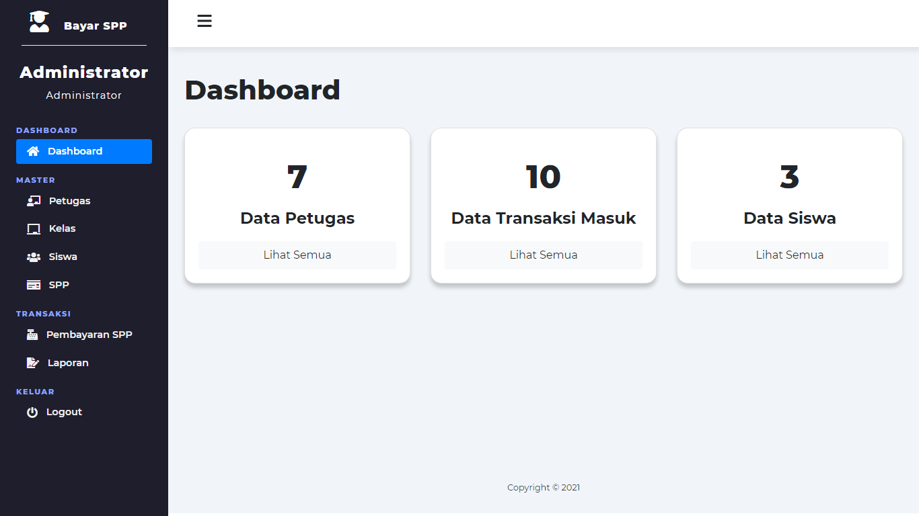

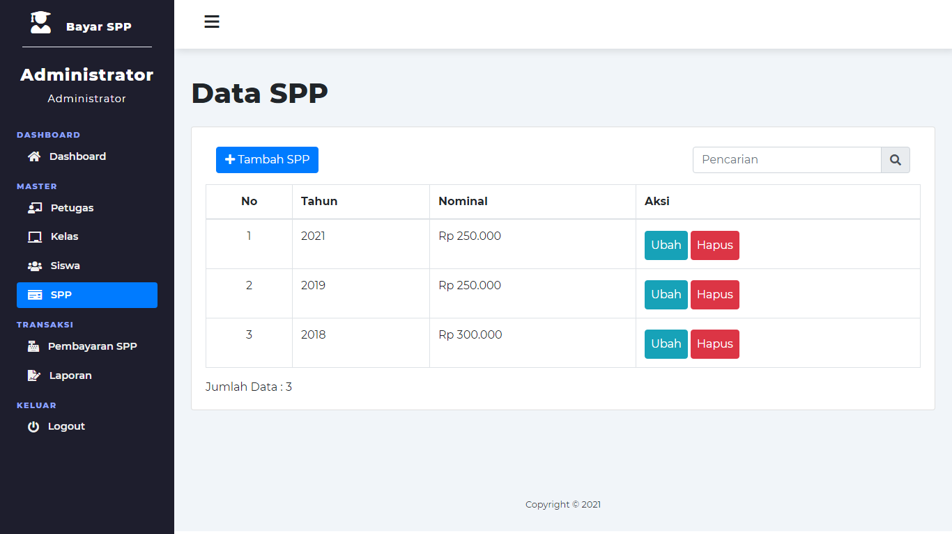

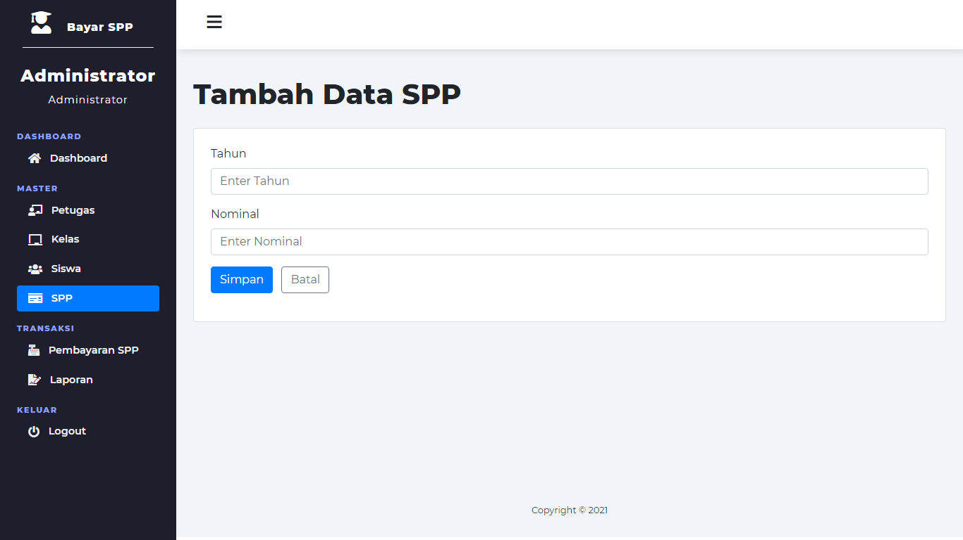

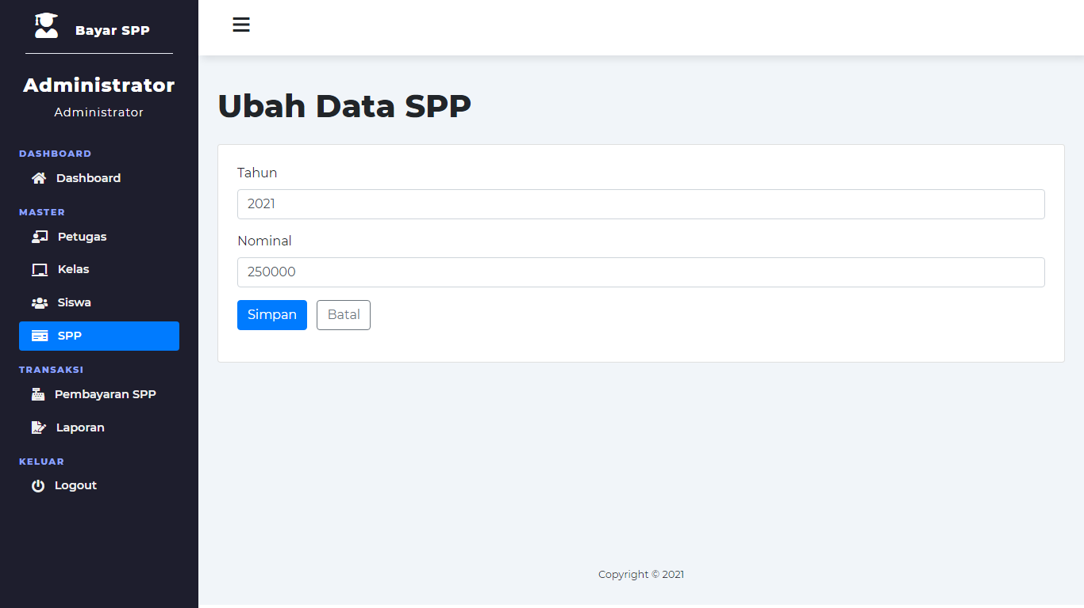

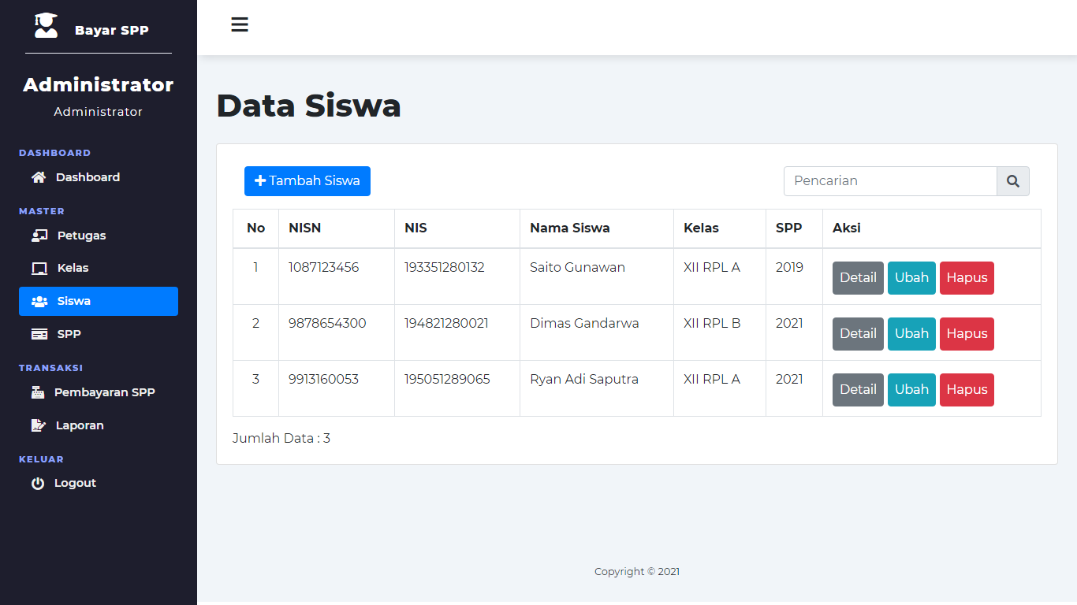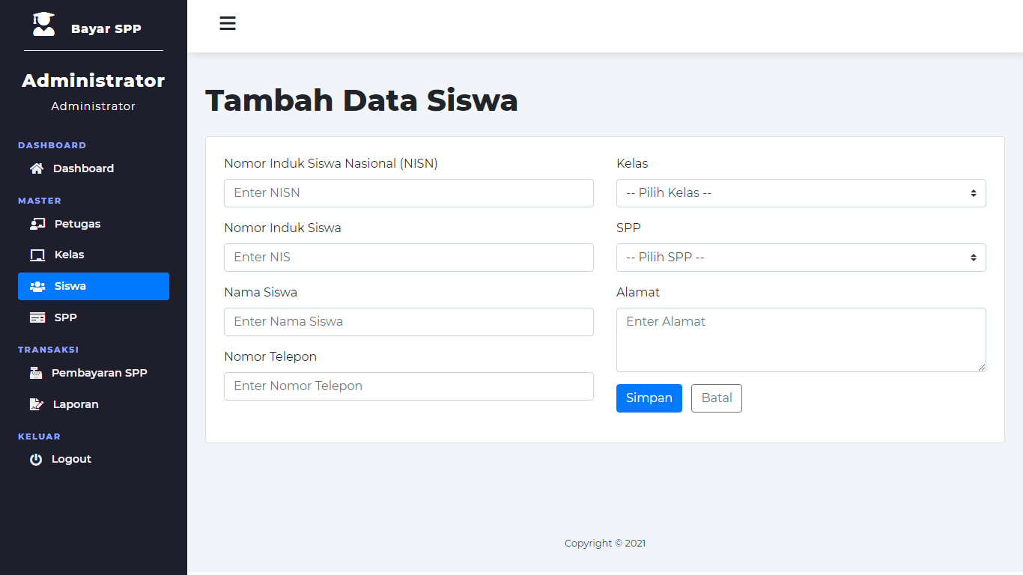

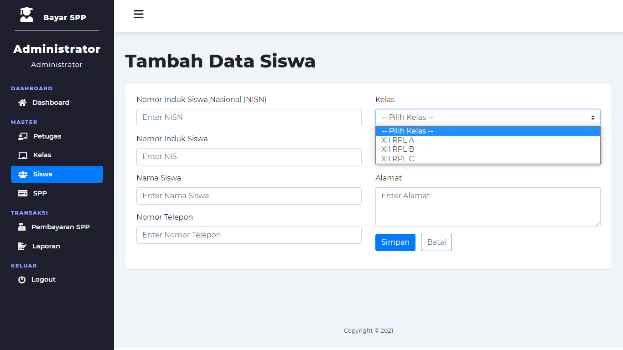

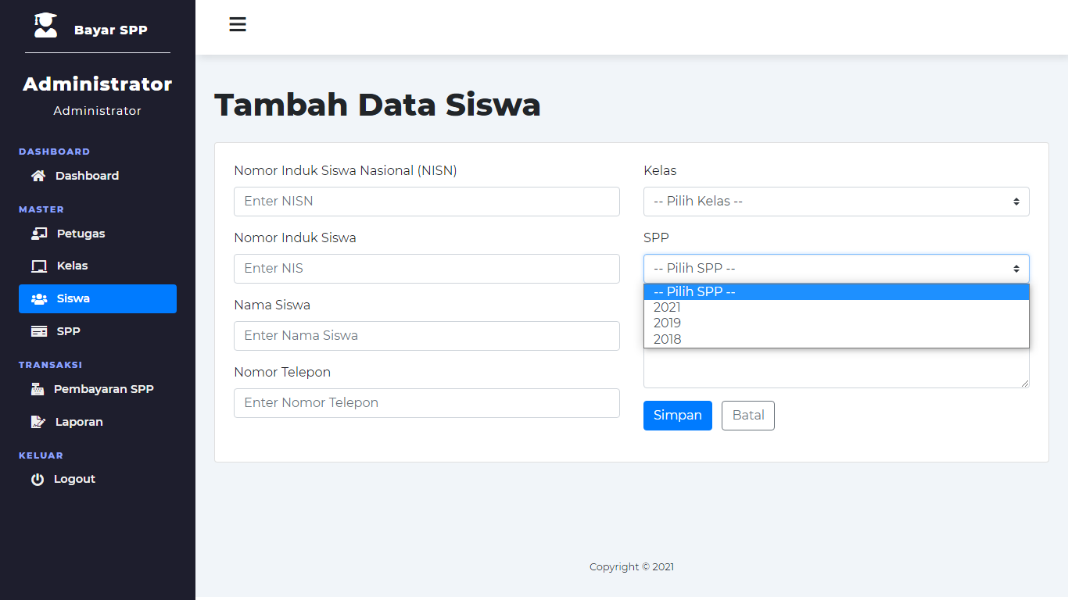

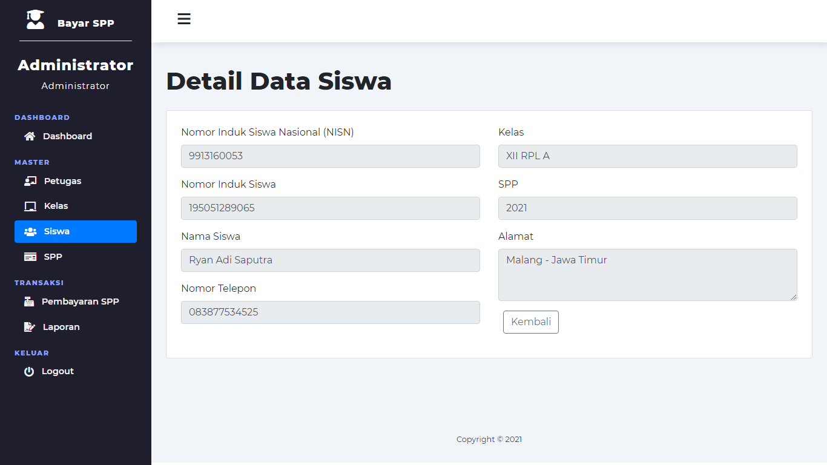

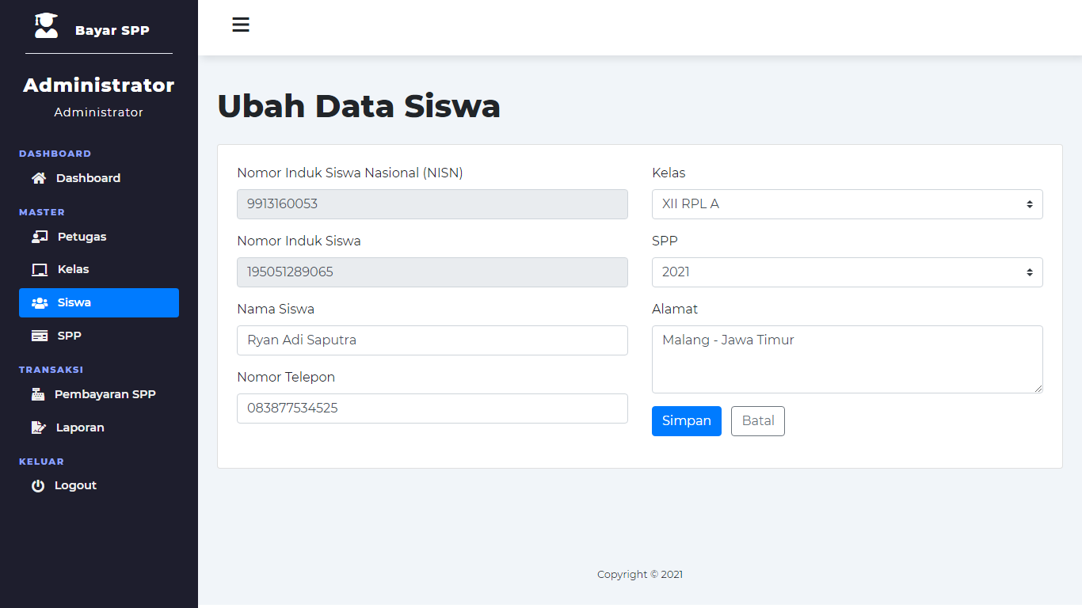

1. Database

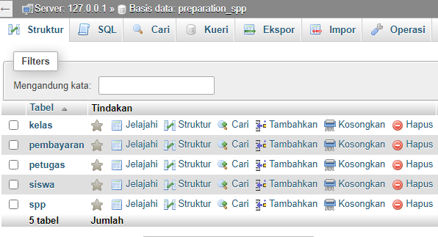

1. Table kelas

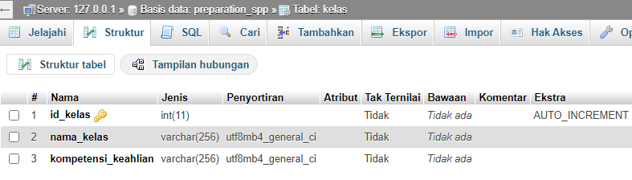

1. Table pembayaran

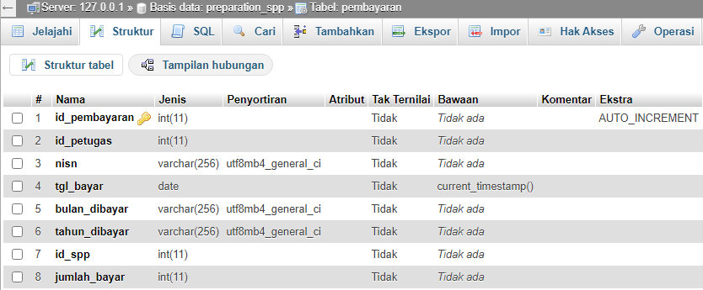

1. Table petugas

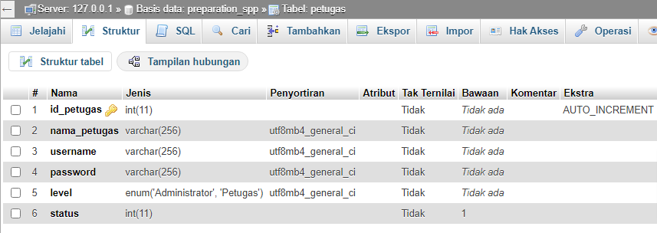

1. Table siswa

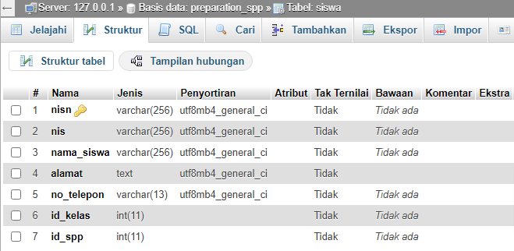

1. Table spp

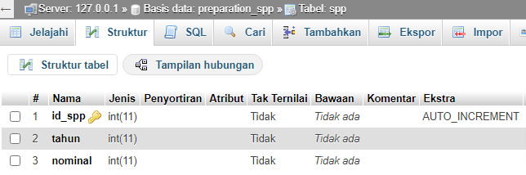

**=== SELAMAT MENGERJAKAN ===**